# Experiment 4: Simple Programs using RISC V Assembly (RARs tool)

|  |  |  |
| --- | --- | --- |
| **Sl No** | **Name** | **ID No** |
| **1** | **Dhruv Makwana** | **2019A3PS0381H** |

**Exercise 5.1: Write RISC V assembly program to calculate the GCD of two numbers stored in data segment. Store the result back to data segment (use successive subtraction based Euclidean Algorithm).**

1. **Copy your image of assembly code for above exercise here.**

Answer: 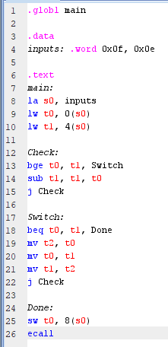

1. **Copy the image of data segment before execution and after execution. Copy the same in your observation book.**

Answer: 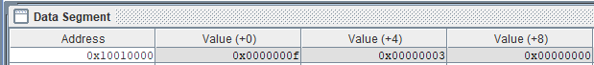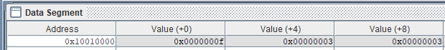

**Exercise 5.2: Write RISC V assembly code for generating N numbers of Fibonacci series in data segment. Assume that the value of N is stored in data segment. (Choose N value to be greater than or equal to 10d)**

For example: .data

N: .word 0x0a

fibseries: .word 0x0, 0x0, 0x0, 0x0, 0x0, 0x0, 0x0, 0x0, 0x0, 0x0

1. **Copy image of your assembly code for above exercise here.**

Answer: 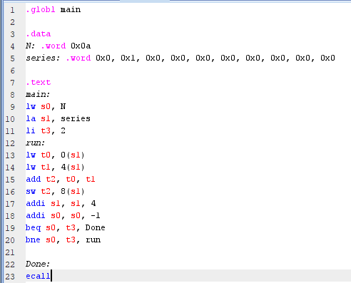

1. **Copy the image of data segment before execution and after execution for this program. Copy the inputs and outputs of this program in your observation book.**

Answer:   


**Exercise 5.3: Try out all the new instructions discussed in class.**

1. **List the instructions that you have tried out (apart from lw, sw, add, addi, sub, beq, bne) Also list the concepts you learnt from this experiment.(Conlcusion/observations)**

Answer: j (Jump) : Allows us to jump to a program label and continue execution from there  
ecall: Initiates a system call, halts the simulator if no input is provided  
auipc (add upper immediate to pc) : Used in the pseudo instruction la  
  
I learned how to better manage program flow in this experiment